PRESS RELEASE

COMMUNICATIONS AND MEDIA TEAM OF THE 43rd ASEAN SUMMIT 2023

No.12/SP/TKM-ASEAN2023/ENG/8/2023

DKI Jakarta Restricts Freight Vehicles on Four Toll Roads During 43rd ASEAN Summit

Jakarta, August 30, 2023 - The Jakarta Provincial Government restricts the freight transport vehicles passing through four toll roads in Jakarta during the 43rd ASEAN Summit from 5—7 September2023.

"The dissemination of this information will be conducted by its officials prior to the ASEAN Summit," said Head of the Jakarta Transportation Agency, Syafrin Liputo, when contacted in Jakarta on Wednesday, 30 August 2023.

This policy is to be adopted in synergy with the Greater Jakarta Transportation Management Agency (BPTJ), the West Java Transportation Agency, the Banten Transportation Agency, and the Indonesian Trucking Association (Aptrindo).

This action is a follow-up to the Decree of Head of BPTJ Number KP-BPTJ 221 of 2023 on Traffic Regulations During the 43rd ASEAN Summit in 2023 on Jakarta Toll Roads.

The operational restrictions for freight transport vehicles will apply to four toll roads ofCawang-Tomang-Pluit, Tomang-Pluit, Kembangan-Tomang, and Pluit-Kamal Muara.

The restrictions will be imposed from 5 September2023, at 00:00 AM until 7 September2023, at 11:49 PM.

In the Decree signed by Acting Head of BPTJ, Agung Rahardjo, on 28 August2023, it is stated that these operational restrictions do not apply to freight transport vehicles carrying fuel or gas, livestock, postal and cash-in-transit deliveries, as well as staple foods.

"Including rice, flour, corn, sugar, vegetables and fruits, meat, fish, vegetable oil, milk, eggs, salt, soybeans, shallots, chili, broiler meat, bottled drinking water, and animal feed," said Syafrin.

Freight transport vehicles not subject to these restrictions must be equipped with a cargo document issued by the owner of the transported goods. The cargo document must contain information about the type of goods being transported, the destination of the shipment, the name and address of the owner of the goods, and it must be affixed to the left side of the front window of the freight vehicle.

The operational restrictions for freight transport vehicles will be indicated by traffic signs installed by toll road operators. Additionally, personnel will be stationed to manage traffic during the ASEAN Summit.

Violations of the instructions and prohibitions indicated by traffic signs, road markings, and traffic signal devices will be subject to penalties under Law Number 22 of 2009 on Traffic and Road Transportation.

Furthermore, to ensure the success organisation of the 43rd ASEAN Summit in Jakarta, the Jakarta Transportation Office has also prepared traffic engineering management.

Several road sections that are subject to traffic engineering are routes to be taken by delegates from their accommodations to the six event venues.

The six ASEAN Summit activity venue locations in Jakarta include the ST Regis Hotel, the ASEAN Secretariat Office, the Jakarta Convention Center (JCC), the Plataran GBK Urban Forest, the Sultan Hotel, and the Merdeka Palace. (Siti Nurhaliza Ant/TR/PR)

***

For further information, please contact:

Director General of Public Information and Communication, Ministry of Communication and Informatics – Usman Kansong (0816785320).

Find more information at http://asean2023.id, https://infopublik.id/kategori/asean-2023, and https://indonesia.go.id/kategori/ragam-asean-2023

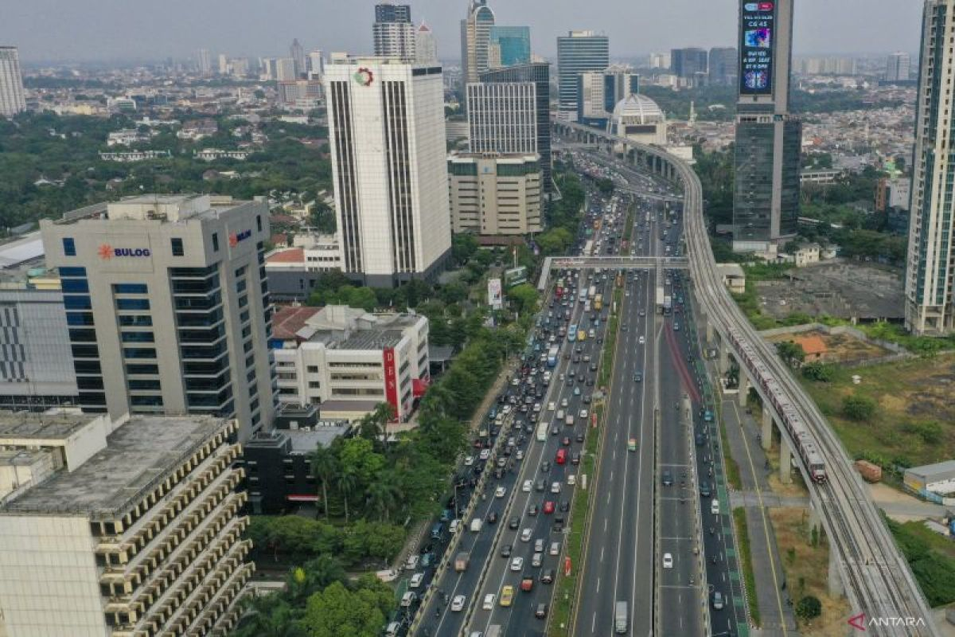

Aerial photo of several cars passing on Inner City Toll Road in Gatot Subroto Street Area, Jakarta, Monday (21/8/2023).

ANTARA FOTO/M Risyal Hidayat/nym.

